Game Design Document

Here are the elements that need to be included in your Game Design Document.

Mare

Xhoana Koca

**Game Pitch**

Have you ever experienced sleep paralyses? If no then with this game you will get to experience how scary our thoughts can get when we are in a position like that. The mind goes on an adventure on how to get rid of the creature that is stopping us from breathing.

**Objectives**

The goal for this game is to get back to your body. This game is for the many people who hope to get rid of sleep paralyses and out of body experiences and cannot succeed in real life. By playing Mare they can visualize how to hurt the creature and some hallucinations that they get to experience in real life. This can act as a healing to the mind and it could be a step closer to actually getting rid of sleep paralyses.

**Controls**

The players can input the next command or they can also click on the verb menu and select the desired command. There is only one object that the players need to input the commands.

**Gameflow**

The rooms in the game Mare are not locked. The player can commute between rooms and also look at the descriptions for desired objects. If the player forgot to pick up an object that is needed for the ending, the player is allowed to go back to the room to get it. The game will not continue without having all of the objects.

**Screenshots**

Include screenshots, with captions, of the game.

This is the first act of the game. The player will have to read this part in order to understand what happened. It is only shown when the player first enters the room. Other times the player will see a different setting.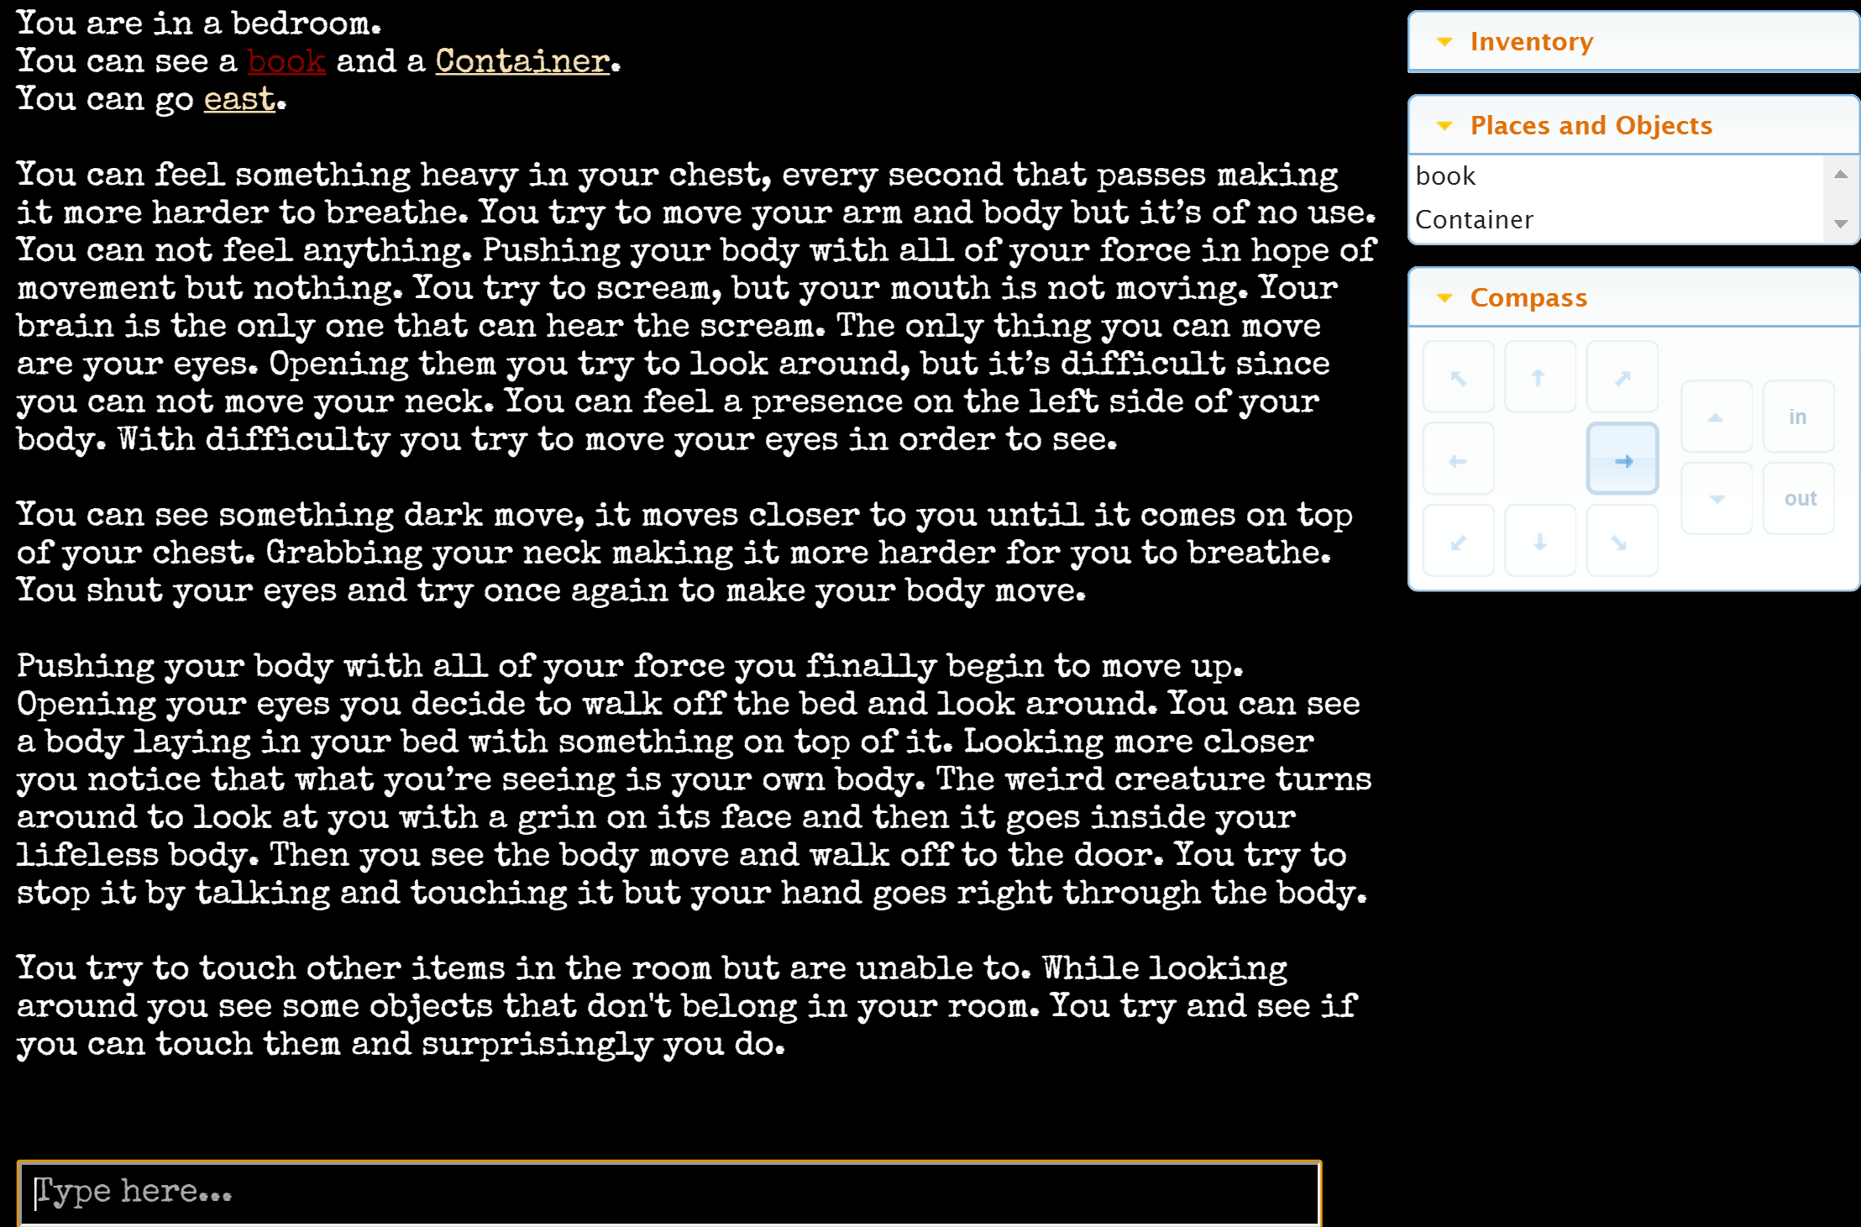



The player needs to pick up book first and then read it. This is done so that the player will not forget it and can also go back to read it in any room.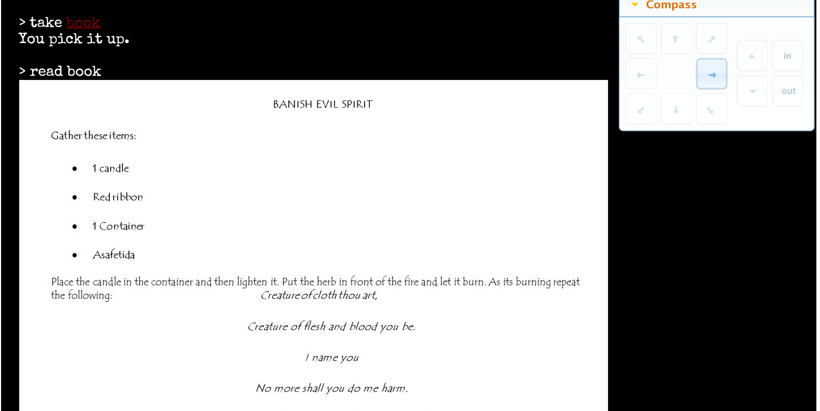  
The hallway can connect to sister’s room and can go downstairs where the living room and bathroom are found.

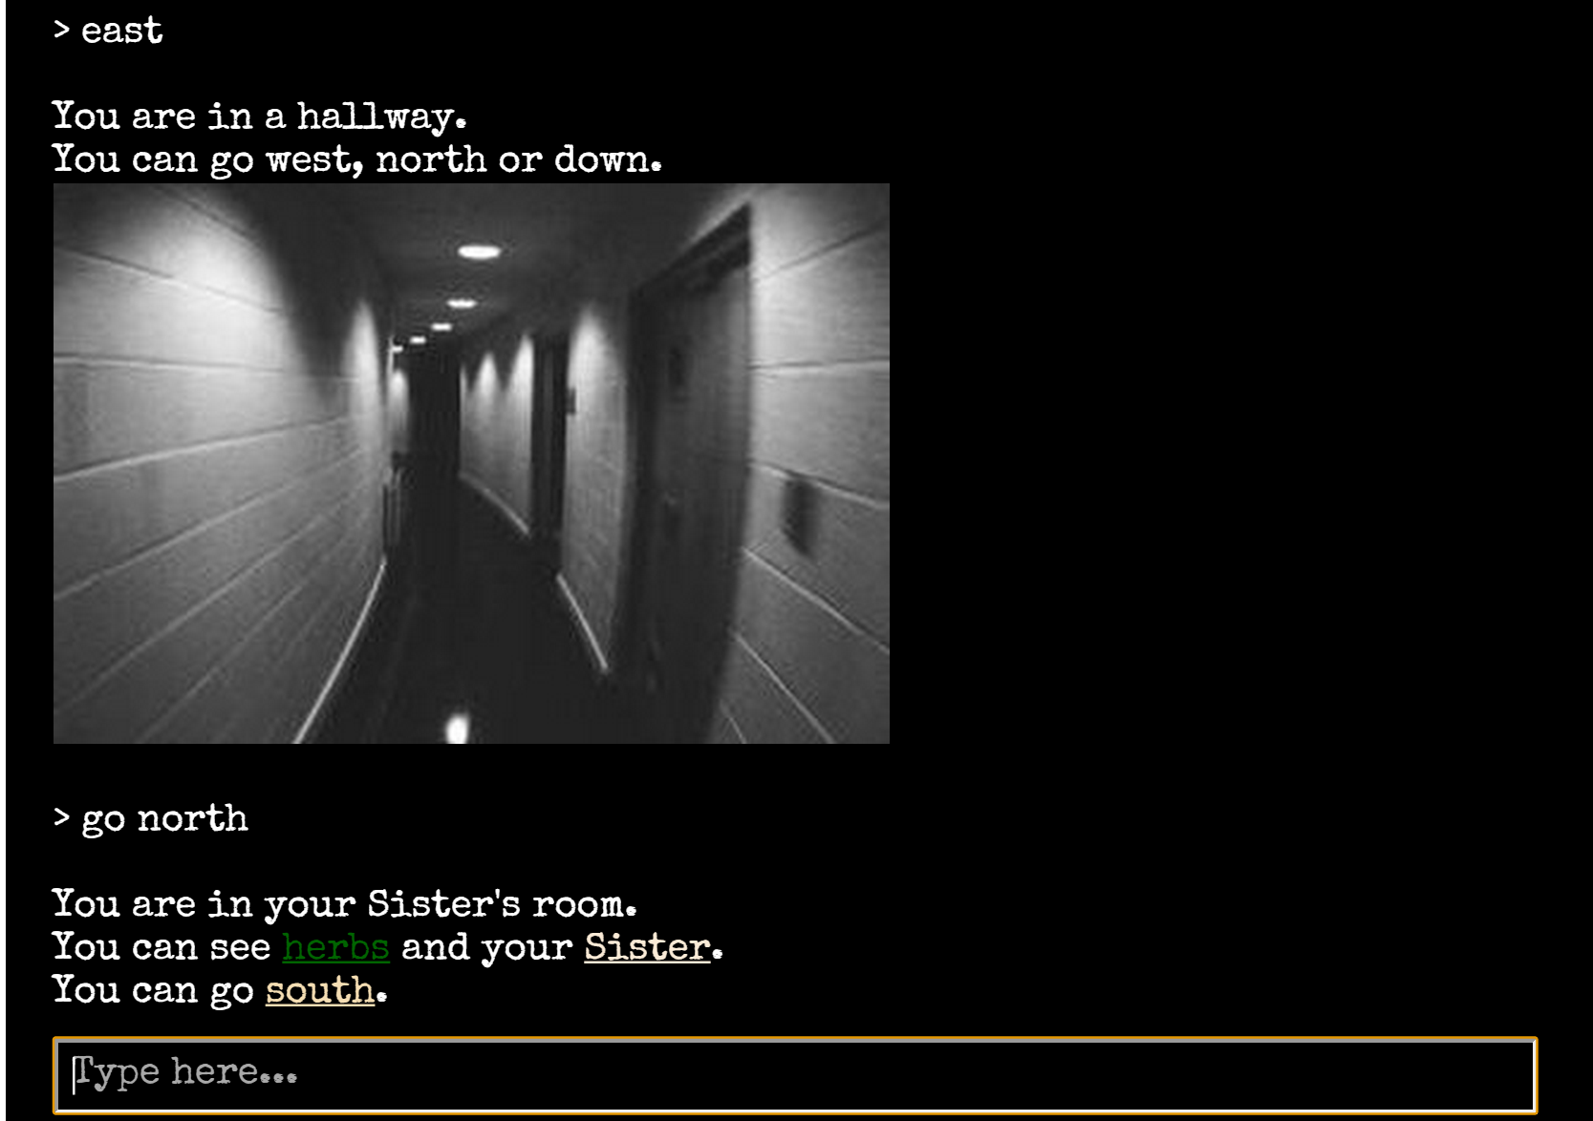

The player can interact with the game and can also add items in inventory

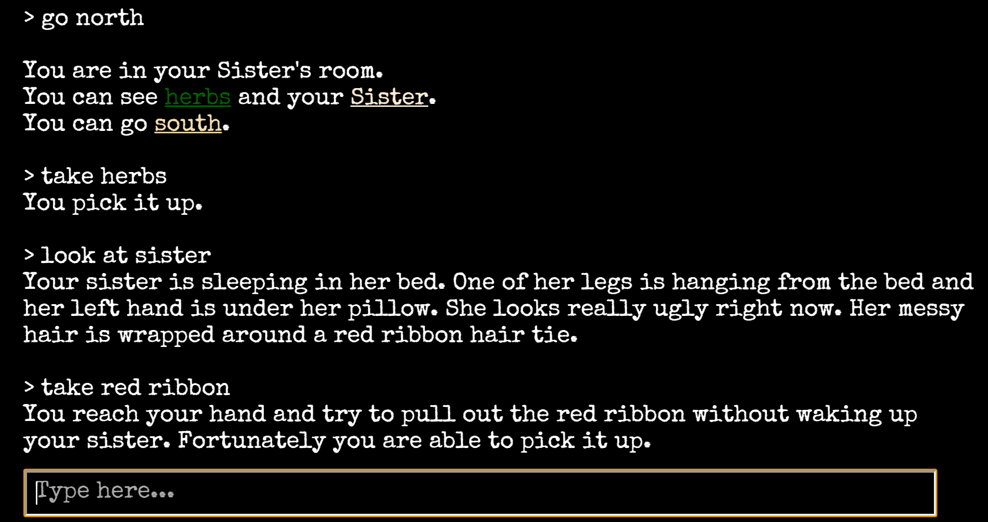

The downstairs go to the living room where the bathroom is also found.

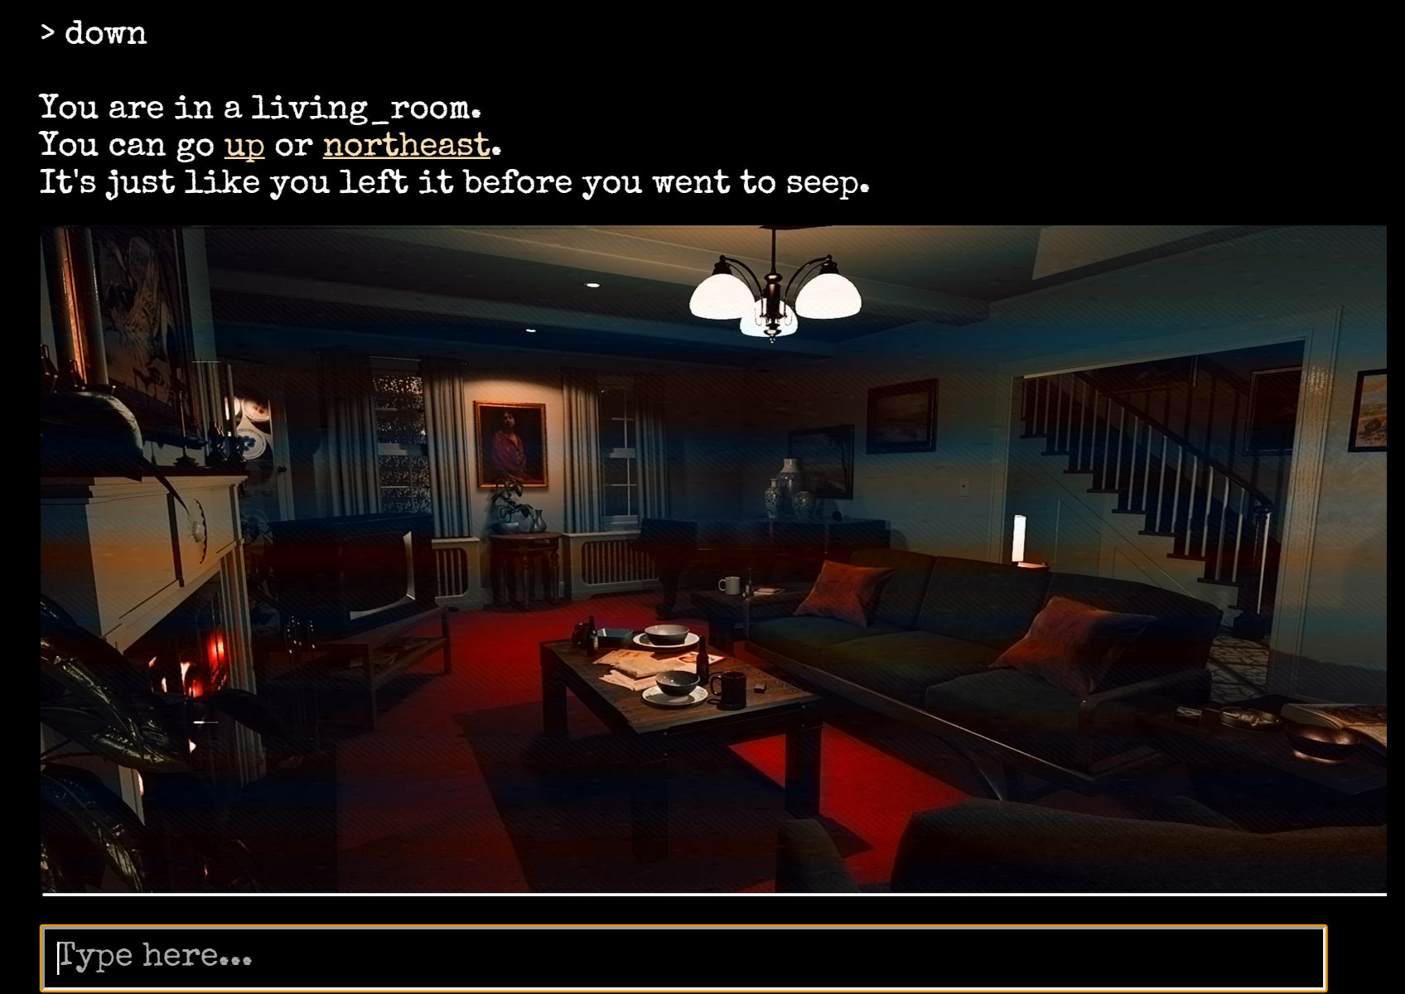

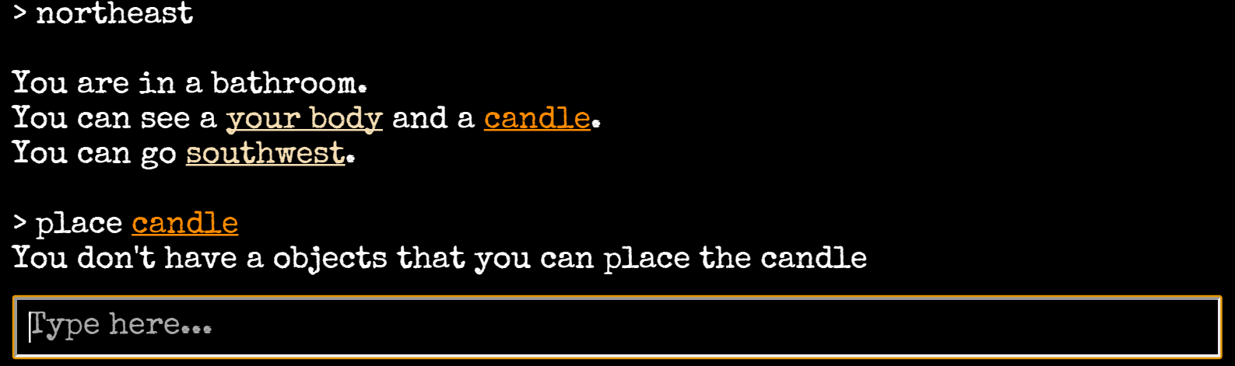

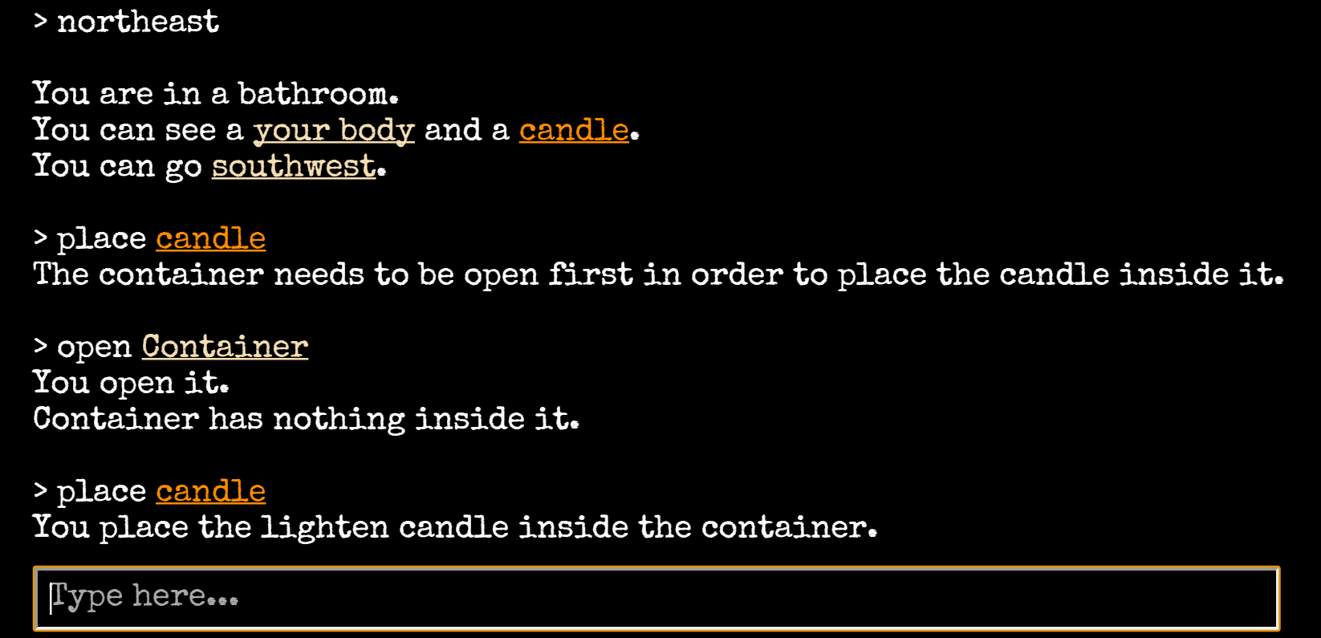

The player will follow the spell that was found in the book. By doing that the player can continue.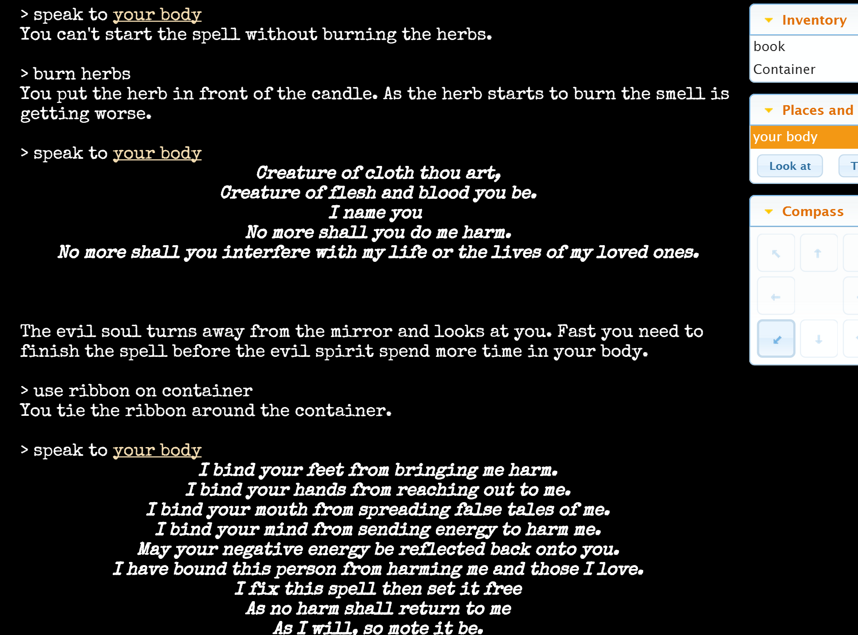

The playere need to follow the spell.